# GENERAL CONTENT

Congratulations! You have chosen the *Foundation* template. This document will outline the template in detail. Please enter all of the content that you would like in your website within this document.   
  
**Items for you to edit are highlighted in YELLOW.**

## HEADER BAR (all pages)



The Foundation template comes with links to up to 5 social media platforms. Please enter the links that you would like to display on your website below.

|  |  |
| --- | --- |
| Social Media Links: | Link to your social media page: |
| Facebook | <http://yourfacebookpagehere.com> |
|  |  |
|  |  |
|  |  |
|  |  |

## FOOTER BAR (all pages)



Please enter any text you’d like to see on the footer of your website into the table below.

|  |
| --- |
| news | contact us  Built with HTML5 and CSS3 [i.e. your tag line goes here]  Copyright © 2015 Your Company Name |

*Please note that the* [*www.worldwidewebpackages.com*](http://www.worldwidewebpackages.com) *link is part of the Nudura program.*

## CORPORATE LOOK/FEEL

Below is information that will help us understand the look/feel you are looking for. Please list your preferences

|  |  |
| --- | --- |
| Your Company Logo: | Please enter your logo here or a path to your company’s logo |
| Company Colours: | Please enter any corporate colours that your company uses on a regular basis. You can refer to the colours with the hexidecimal values or with RGB values. |
| Background preference: | Do you have a colour preference for the background of your website? |
| Font Preferences: | Do you have any font preferences? If yes, please attach the fonts or refer to online Google Fonts by name. |
| Please description of look that you like: | Please enter a description of the “look” you are after for your website. Do you want it to look corporate or edgy? Do you want clean lines are heavy textures in the design? You can include links of sites that you like here. |
| Any other description here: | Please enter any other descriptions that will help us get a clear idea of your likes and dislikes in regards to “look” and “feel”. |

## MAIN MENU (site map)

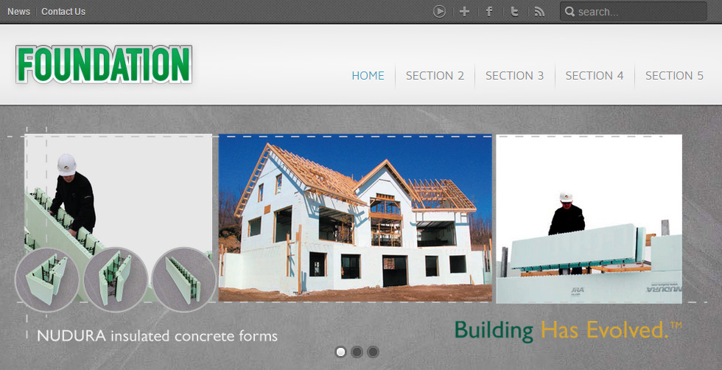

Fill in the boxes below with the sections that you would like in your website. Each section counts as a page and *Foundation* includes **5 pages**. Any pages beyond that will be an additional cost of $100/page. Note: You don’t have to have all of the pages in the first row. You can have some drop down menus if that works for your needs. Just click on the row of boxes below and enter your text in the “text pane” that shows up on the left side. For drop down items, simply hit “enter” and “tab” to indent a bullet and a drop down box will appear.

# HOMEPAGE

## HOMEPAGE SLIDESET

**The Setup (side-by-side, stacked images):**   
Each single slide is comprised of separate images that animate on sequentially to build the slide’s content. A good example of this is to look at the second slide on the Foundation template which shows the letters: H, E, L, L, O.



These animate on screen to form the word HELLO. Each letter is a separate image. We stack the images together in the control panel to build the animation that actually makes the slide.

The only caveat is that each image in the Homepage Slideset has to be 210 pixels high. Widths can be variable and we can add as many separate images as you like to build up each slide. Each image gets stacked up next to the previous one to build up the final slide’s image.

**Single Image Slide:**The first slide of the Home page of the Foundation template shows a slide with only 1 large image. Basically, the first slide is not comprised of side-by-side-stacked images.

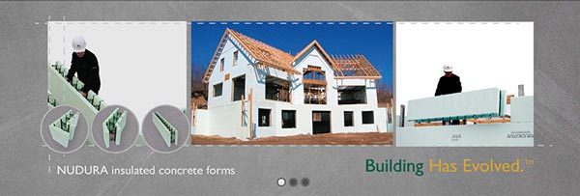

Fill out the tables below with the text and location/filenames of the images that you would like in your homepage slideset. *Foundation* includes 3 different slides playing in the homepage (as shown below). Additional slides will be $100/slide.

|  |  |  |
| --- | --- | --- |
| Item: | Statement: | Image: |
| 1 | Your message here | Image file name |
| 2 | Your message here | Image file name |
| 3 | Your message here | Image file name |
| 4 | Your message here | Image file name |
| 5 | Your message here | Image file name |
| 6 | Your message here | Image file name |
|  |  |  |

## HOMEPAGE GALLERY

Fill in the table below with the content you would like in your homepage “gallery”. *Foundation* includes up to 6 pages in the homepage Gallery.

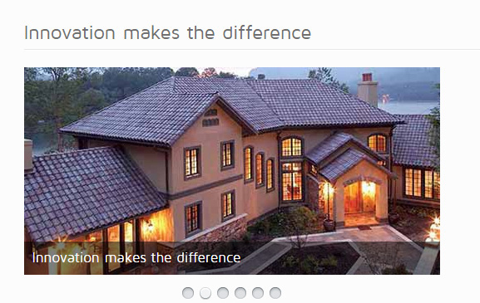

**Gallery Title:** Innovation Makes the Difference

|  |  |  |
| --- | --- | --- |
| Item: | Statement: | Image: |
| 1 | Your message here | Image file name |
| 2 | Your message here | Image file name |
| 3 | Your message here | Image file name |
| 4 | Your message here | Image file name |
| 5 | Your message here | Image file name |
| 6 | Your message here | Image file name |
|  |  |  |

## HOMEPAGE NEWS SLIDESHOW

|  |  |
| --- | --- |
|  | This is the homepage news slideshow. The text in entered via a simple **Widgetkit** item (Components / **Widgetkit**) and can be changed regularly and easily. Up to 3 news items are included in the *Foundation* template. You can add/remove and change the order of news items as you see fit. Each news item has the option of adding a link or a caption but it doesn’t have to.  Please fill in the content below for your 3 starter news items. |

Main Title: (of the News Slideshow)  
**Latest News**

|  |  |  |  |
| --- | --- | --- | --- |
| Item Title | Text Content: | Link: (optional) | Caption: (optional) |
| News Item A | Your text content goes here. | Check All Features  (link to Features page) | This is a caption |
| News Item B | Your text content goes here. | Check All Features  (link to Features page) | This is a caption |
| News Item C | Your text content goes here. | Check All Features  (link to Features page) | This is a caption |

## HOMEPAGE GALLERY

You may want to have an image gallery on your homepage. This is an area to show your project images. Each image will enlarge when clicked on so please ensure that we have images of suitable size to work with. The Foundation template comes with up to 8 images in the image gallery.

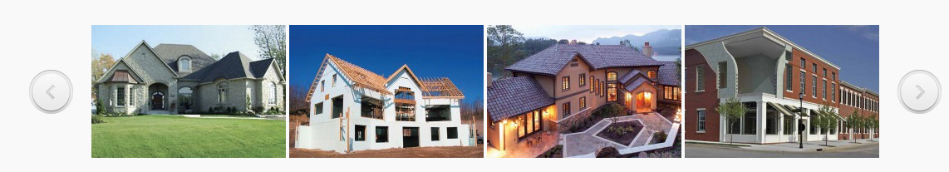

|  |  |
| --- | --- |
| #: | Image: |
| 1 | The path or filename for your image |
| 2 | The path or filename for your image |
| 3 | The path or filename for your image |
| 4 | The path or filename for your image |
| 5 | The path or filename for your image |
| 6 | The path or filename for your image |
| 7 | The path or filename for your image |
| 8 | The path or filename for your image |

## HOMEPAGE BODY TEXT

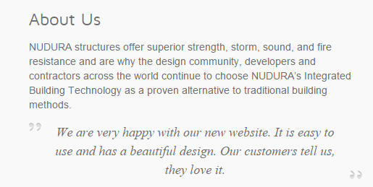

|  |
| --- |
| Title: |
| About Us |
| Text Content: |
| NUDURA structures offer superior strength, storm, sound, and fire resistance and are why the design community, developers and contractors across the world continue to choose NUDURA’s Integrated Building Technology as a proven alternative to traditional building methods. |
| Quote: (optional) |
| We are very happy with our new website. It is easy to use and has a beautiful design. Our customers tell us, they love it. |

## HOMEPAGE QUICK LINKS

This is a set of links that you want to include so that you can direct the user to where you’d like them to go first.

|  |  |
| --- | --- |
| Title: | |
| Company | |
| Link Text: | **Links to ...** |
| Our Team | The Team page |
| Our History | The History subtitle on the About Us page |
| Awards | Awards page |
| We are hiring | http://www.google.com |
|  |  |
|  |  |

## HOMEPAGE CONTACT

The contact information that you’d like to display on the homepage

|  |
| --- |
| Title: |
| Contact Us |
| Content: |
| 123 Your Street West  Your Town, CA  [contact@worldwidewebpackages.com](mailto:contact@worldwidewebpackages.com)  1-555-123-4567 |

# SECTION 2 (to be renamed)

This is an example of what your sections could look like. There is a lot of flexibility. You can bullets, or links to other sites. You can also add images.

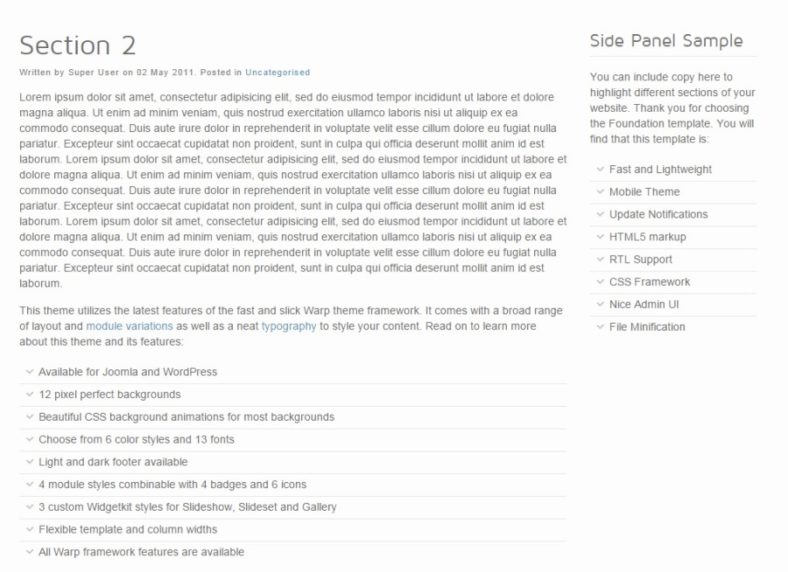

Please use the table below to add the content that you want to appear in this section. Don’t worry about your text formatting (sizes, etc)... we’ll make sure the content is formatted properly for the site.

|  |  |
| --- | --- |
| Page Heading/Title: | |
| Section 2 | |
| Main Content: | **Side Bar Content: (optional)** |
| Please enter your content here.  Lorem ipsum dolor sit amet, consectetur adipisicing elit, sed do eiusmod tempor incididunt ut labore et dolore magna aliqua. Ut enim ad minim veniam, quis nostrud exercitation ullamco laboris nisi ut aliquip ex ea commodo consequat. | Please enter your content here.  Any information you’d like on the side panel goes here.  For example; you may want to feature some highlights about your company or link to some of your projects here. |

# SECTION 3 (to be renamed)

Please use the table below to add the content that you want to appear in this section. Don’t worry about your text formatting (sizes, etc)... we’ll make sure the content is formatted properly for the site.

|  |  |
| --- | --- |
| Page Heading/Title: | |
| Section 3 | |
| Main Content: | **Side Bar Content: (optional)** |
| Please enter your content here.  Lorem ipsum dolor sit amet, consectetur adipisicing elit, sed do eiusmod tempor incididunt ut labore et dolore magna aliqua. Ut enim ad minim veniam, quis nostrud exercitation ullamco laboris nisi ut aliquip ex ea commodo consequat. | Please enter your content here.  Any information you’d like on the side panel goes here.  For example; you may want to feature some highlights about your company or link to some of your projects here. |

# SECTION 4 (to be renamed)

Please use the table below to add the content that you want to appear in this section. Don’t worry about your text formatting (sizes, etc)... we’ll make sure the content is formatted properly for the site.

|  |  |
| --- | --- |
| Page Heading/Title: | |
| Section 4 | |
| Main Content: | **Side Bar Content: (optional)** |
| Please enter your content here.  Lorem ipsum dolor sit amet, consectetur adipisicing elit, sed do eiusmod tempor incididunt ut labore et dolore magna aliqua. Ut enim ad minim veniam, quis nostrud exercitation ullamco laboris nisi ut aliquip ex ea commodo consequat. | Please enter your content here.  Any information you’d like on the side panel goes here.  For example; you may want to feature some highlights about your company or link to some of your projects here. |

# SECTION 5 (to be renamed)

Please use the table below to add the content that you want to appear in this section. Don’t worry about your text formatting (sizes, etc)... we’ll make sure the content is formatted properly for the site.

|  |  |
| --- | --- |
| Page Heading/Title: | |
| Section 5 | |
| Main Content: | **Side Bar Content: (optional)** |
| Please enter your content here.  Lorem ipsum dolor sit amet, consectetur adipisicing elit, sed do eiusmod tempor incididunt ut labore et dolore magna aliqua. Ut enim ad minim veniam, quis nostrud exercitation ullamco laboris nisi ut aliquip ex ea commodo consequat. | Please enter your content here.  Any information you’d like on the side panel goes here.  For example; you may want to feature some highlights about your company or link to some of your projects here. |

# SEO (Search Engine Optimization)

We provide standard SEO in all of our web packages. Please fill out the tables below to include **keywords** and **descriptions** for every page of your site. This meta data content is not visible on-screen. It’s only used by search engines to help determine the purpose/intention of the page.

**Global Meta Data: (Keywords and Description)**  
The table below is for you to specify the meta data (keywords and description) that will be **applied globally to every page** of your site dynamically.

|  |  |  |
| --- | --- | --- |
| Section / Page Title: | Meta Keywords: | Meta Description: |
| *NOTES:* | *Please enter a list of words that a user might type in a search engine to find this particular page.*  *No repeating words. Keep within 160 to 255 characters.* | *Meta descriptions can be any length, but search engines generally truncate snippets longer than 160 characters. It is best to keep meta descriptions between* ***150 and 160 characters****.* |
| GLOBAL  META DATA  (for every page of the site) | Your, generic, comma, separated, list, of, words, goes, here | A short and concise description of the website as a whole. The description is typically displayed on the search results page of many search engines. |

**Individual Page Meta Data: (Keywords and Descriptions)**  
OPTIONAL. You can override the global meta data (above) and specify meta data unique to the particular web page. This is optional. If you add meta data in the chart below, we will use it to override the global meta data for that particular page.

|  |  |  |
| --- | --- | --- |
| Section / Page Title: | Meta Keywords: | Meta Description: |
| *NOTES:* | *Please enter a list of words that a user might type in a search engine to find this particular page.*  *No repeating words. Keep within 160 to 255 characters.* | *Meta descriptions can be any length, but search engines generally truncate snippets longer than 160 characters. It is best to keep meta descriptions between* ***150 and 160 characters****.* |
| Home / Welcome | Your, comma, separated, list, of, words, goes, here | A short and concise description of this page’s content would go here. The description is typically displayed on the search results page of many search engines. |
| Section 2 |  |  |
| Section 3 |  |  |
| Section 4 |  |  |
| Section 5 |  |  |